Q1.

-- Create the database
CREATE DATABASE railway_reservation;

-- Connect to the database
-- \c railway_reservation

-- Create the TRAIN table
CREATE TABLE TRAIN (
TRAIN_NO INT PRIMARY KEY,
TRAIN_NAME VARCHAR(20),
DEPART_TIME TIME,
ARRIVAL_TIME TIME,
SOURCE_STN VARCHAR(20),
DEST_STN VARCHAR(20),
NO_OF_RES_BOGIES INT,
BOGIE_CAPACITY INT
);

-- Create the PASSENGER table
CREATE TABLE PASSENGER (
PASSENGER_ID INT PRIMARY KEY,
PASSENGER_NAME VARCHAR(20),
ADDRESS VARCHAR(30),
AGE INT,
GENDER CHAR(1) -- Changed to CHAR(1)
);

-- Create the TICKET table (M:M relationship)
CREATE TABLE TICKET (
TRAIN_NO INT,
PASSENGER_ID INT,
TICKET_NO INT PRIMARY KEY,
BOGIE_NO INT,
NO_OF_BERTHS INT,
DATE DATE,
TICKET_AMT DECIMAL(7,2),
STATUS CHAR(1), -- Changed to CHAR(1)
FOREIGN KEY (TRAIN_NO) REFERENCES TRAIN(TRAIN_NO),
FOREIGN KEY (PASSENGER_ID) REFERENCES PASSENGER(PASSENGER_ID)
);

-- Insert sample data into TRAIN
INSERT INTO TRAIN (TRAIN_NO, TRAIN_NAME, DEPART_TIME, ARRIVAL_TIME, SOURCE_STN, DEST_STN, NO_OF_RES_BOGIES, BOGIE_CAPACITY) VALUES
(101, 'Rajdhani Exp', '17:00:00', '21:00:00', 'Delhi', 'Mumbai', 10, 72),
(102, 'Shatabdi Exp', '06:00:00', '12:00:00', 'Mumbai', 'Pune', 5, 72),
(103, 'Duronto Exp', '22:00:00', '08:00:00', 'Kolkata', 'Chennai', 12, 72);

-- Insert sample data into PASSENGER
INSERT INTO PASSENGER (PASSENGER_ID, PASSENGER_NAME, ADDRESS, AGE, GENDER) VALUES
(1, 'Amit Sharma', '123 MG Road, Delhi', 30, 'M'),
(2, 'Priya Patel', '456 Linking Rd, Mumbai', 25, 'F'),
(3, 'Rahul Singh', '789 Park St, Kolkata', 40, 'M');

-- Insert sample data into TICKET
INSERT INTO TICKET (TRAIN_NO, PASSENGER_ID, TICKET_NO, BOGIE_NO, NO_OF_BERTHS, DATE, TICKET_AMT, STATUS) VALUES
(101, 1, 1001, 1, 2, '2024-01-20', 2500.00, 'C'),
(102, 2, 1002, 3, 1, '2024-01-20', 1200.00, 'C'),
(101, 3, 1003, 2, 3, '2024-01-21', 3750.00, 'W');

-- a) Trigger to validate train arrival time must be less than train departure time.
CREATE OR REPLACE FUNCTION validate_train_times()
RETURNS TRIGGER AS $$
BEGIN
IF NEW.ARRIVAL_TIME >= NEW.DEPART_TIME THEN
RAISE EXCEPTION 'Arrival time must be less than departure time.';
END IF;
RETURN NEW;
END;
$$ LANGUAGE plpgsql;

CREATE TRIGGER check_train_times
BEFORE INSERT OR UPDATE ON TRAIN
FOR EACH ROW
EXECUTE FUNCTION validate_train_times();

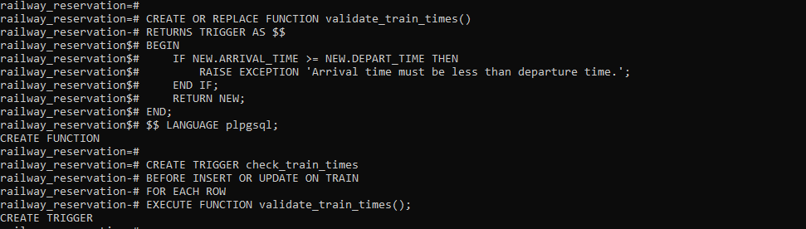

-- b) Trigger to display message 'Ticket is updated' after changing ticket information.
CREATE OR REPLACE FUNCTION display_ticket_updated()
RETURNS TRIGGER AS $$
BEGIN
RAISE NOTICE 'Ticket is updated';
RETURN NEW;
END;
$$ LANGUAGE plpgsql;

CREATE TRIGGER after_ticket_update
AFTER UPDATE ON TICKET
FOR EACH ROW
EXECUTE FUNCTION display_ticket_updated();
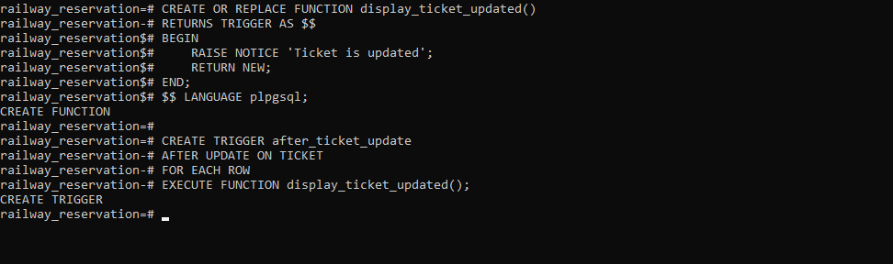

Q.2
-- Create the database
CREATE DATABASE bus_transport;

-- Connect to the database
-- \c bus_transport;

-- Create the BUS table
CREATE TABLE BUS (
BUS_NO INT PRIMARY KEY,
CAPACITY INT NOT NULL,
DEPOT_NAME VARCHAR(20)
);

-- Create the ROUTE table
CREATE TABLE ROUTE (
ROUTE_NO INT PRIMARY KEY,
SOURCE CHAR(20),
DESTINATION CHAR(20),
NO_OF_STATIONS INT
);

-- Create the DRIVER table
CREATE TABLE DRIVER (
DRIVER_NO INT PRIMARY KEY,
DRIVER_NAME CHAR(20),
LICENSE_NO INT UNIQUE,
ADDRESS CHAR(20),
D_AGE INT,
SALARY FLOAT
);

-- Create the BUS_ROUTE table (M:1 relationship - corrected)
CREATE TABLE BUS_ROUTE (
BUS_NO INT,
ROUTE_NO INT,
PRIMARY KEY (BUS_NO, ROUTE_NO), -- Added a primary key
FOREIGN KEY (BUS_NO) REFERENCES BUS(BUS_NO),
FOREIGN KEY (ROUTE_NO) REFERENCES ROUTE(ROUTE_NO)
);

-- Create the BUS_DRIVER table (M:M relationship)
CREATE TABLE BUS_DRIVER (
BUS_NO INT,
DRIVER_NO INT,
DATE_OF_DUTY DATE,
SHIFT VARCHAR(10), -- Changed SHIFT to VARCHAR
PRIMARY KEY (BUS_NO, DRIVER_NO, DATE_OF_DUTY), -- Added a primary key
FOREIGN KEY (BUS_NO) REFERENCES BUS(BUS_NO),
FOREIGN KEY (DRIVER_NO) REFERENCES DRIVER(DRIVER_NO)
);

-- Insert sample data into BUS
INSERT INTO BUS (BUS_NO, CAPACITY, DEPOT_NAME) VALUES
(101, 50, 'Central Depot'),
(102, 40, 'Eastern Depot'),
(103, 60, 'Central Depot'),
(104, 55, 'Western Depot');

-- Insert sample data into ROUTE
INSERT INTO ROUTE (ROUTE_NO, SOURCE, DESTINATION, NO_OF_STATIONS) VALUES
(1, 'A', 'B', 10),
(2, 'C', 'D', 15),
(3, 'A', 'D', 20);

-- Insert sample data into DRIVER
INSERT INTO DRIVER (DRIVER_NO, DRIVER_NAME, LICENSE_NO, ADDRESS, D_AGE, SALARY) VALUES
(1001, 'John Smith', 12345, '1 Main St', 35, 50000.00),
(1002, 'Jane Doe', 67890, '2 Oak Ave', 28, 45000.00),
(1003, 'David Lee', 24680, '3 Pine Ln', 52, 60000.00),
(1004, 'Sarah Kim', 13579, '4 Elm Rd', 48, 55000.00);

-- Insert sample data into BUS_ROUTE
INSERT INTO BUS_ROUTE (BUS_NO, ROUTE_NO) VALUES
(101, 1),
(102, 2),
(103, 1),
(104, 3);

-- Insert sample data into BUS_DRIVER
INSERT INTO BUS_DRIVER (BUS_NO, DRIVER_NO, DATE_OF_DUTY, SHIFT) VALUES
(101, 1001, '2024-01-20', 'Morning'),
(101, 1002, '2024-01-20', 'Evening'),
(102, 1003, '2024-01-21', 'Morning'),
(103, 1001, '2024-01-21', 'Evening'),
(104, 1004, '2024-01-22', 'Morning');

-- a) Trigger to validate driver age before insert or update
CREATE OR REPLACE FUNCTION validate_driver_age()
RETURNS TRIGGER AS $$
BEGIN
IF NEW.D_AGE >= 18 AND NEW.D_AGE <= 50 THEN
RAISE NOTICE 'Valid entry';
RETURN NEW;
ELSE
RAISE EXCEPTION 'Invalid driver age. Age must be between 18 and 50.';
END IF;
END;
$$ LANGUAGE plpgsql;

CREATE TRIGGER check_driver_age
BEFORE INSERT OR UPDATE ON DRIVER
FOR EACH ROW
EXECUTE FUNCTION validate_driver_age();
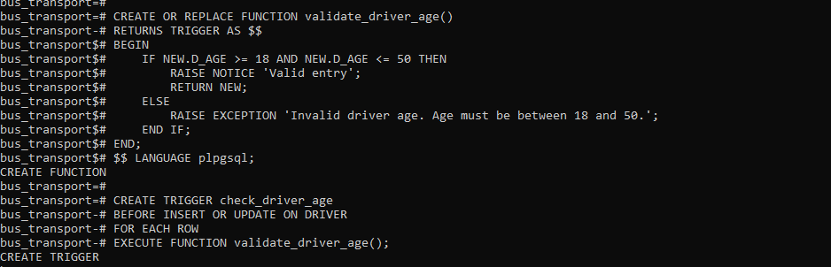

-- b) Trigger to display message after deleting a bus with capacity < 10
CREATE OR REPLACE FUNCTION check_bus_capacity_on_delete()
RETURNS TRIGGER AS $$
BEGIN
IF OLD.CAPACITY < 10 THEN
RAISE NOTICE 'Bus with capacity % deleted.', OLD.CAPACITY;
END IF;
RETURN OLD;
END;
$$ LANGUAGE plpgsql;

CREATE TRIGGER after_delete_bus
AFTER DELETE ON BUS
FOR EACH ROW
EXECUTE FUNCTION check_bus_capacity_on_delete();
